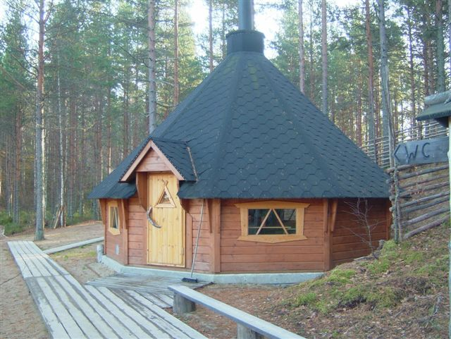 | 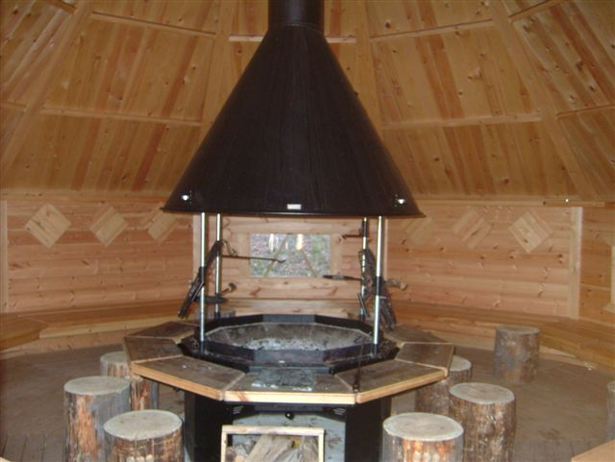
 | 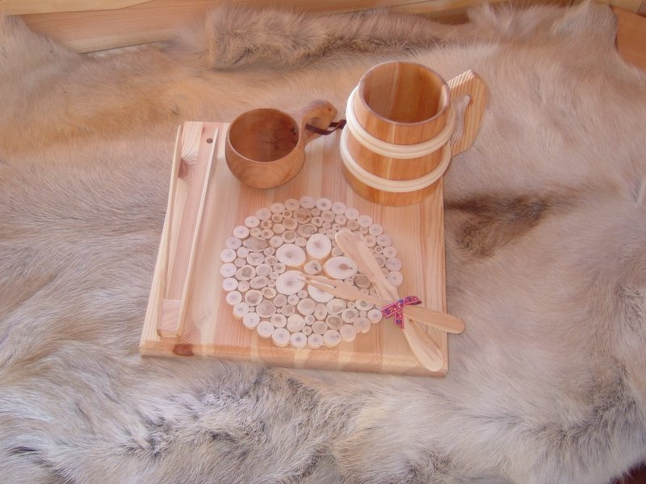
 | 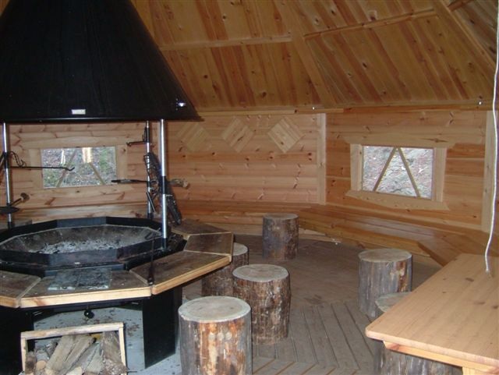
Finnish BBQ Hut 28.8 m² – £14,700
10 Sides – Seating for 40 persons
Roof projection: 0.37 m

Consists of:
Walls: 40 mm double tongue and groove logs from Red Pine.
6.00m x 6.05m
Flooring: Decking that can be removed for cleaning.
Roof: 20 mm tongue and groove roof boards.
Apex height: 4.60 m
Doors: 1 door
Windows: 4 windows (1 window opens), double glazed

Included Equipment:
An octagonal grill Toggle tables
A round table around the grill Flower boxes
A grill set Reindeer skins
A brick pan Juniper underlay
A steel kettle

Extras:
Larger windows Call for price
Build Call for price
 | 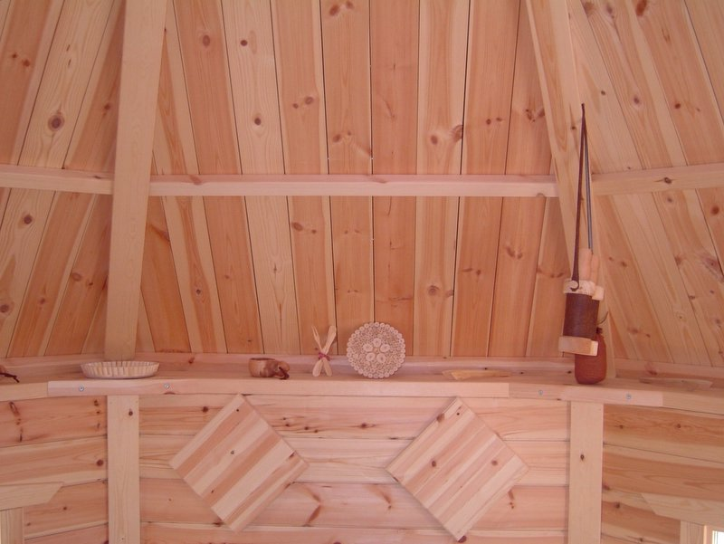
 | 